# ABC Inventory Management

# Test Scenario: Beta Test Scenario 1

Table of Contents

ABC Inventory Management 1

Test Scenario: Beta Test Scenario 1 1

Scenario Description 3

Version Control 3

Test Scripts 3

Use Case 3

Test Components/ Requirements 3

User Groups 3

Test Scripts 3

ES001: Edit Staff Details (Manage Staff) Script 3

Script Description 3

Testing Requirements 4

Setup 4

Teardown 4

Script Steps 4

Result Screenshots 5

LI001 Login Script 6

Script Description 6

Testing Requirements 6

Setup 7

Teardown 7

Script Steps 7

Result Screenshots 7

# Scenario Description

This scenario is intended to test a business condition when an existing warehouse staff needs to update a store staff’s password because the store staff forgot their password. The store staff requests a warehouse staff to update his/her password through email. It is assumed that the warehouse staff has verified the email and is ready to change the password. After changing the password, it is forwarded to the store staff through external email address after which the store staff attempts to login to the system.

# Version Control

|  |  |  |  |
| --- | --- | --- | --- |
| Version Number | Date | Author | Description |
| 6.0 | 25/09/2018 | Shirish Maharjan | Initial Draft |
| 6.1 | 28/09/2018 | Shirish Maharjan | First Version (Iteration 6) |

# Test Scripts

The following are the test scripts that will cover this scenario:

* ES001 Edit Staff Details (Manage Staff) Script
* LI001 Login Script

# Use Case

The use case covered by this test scenario is as follows:

* Login/ Logout
* Edit Staff Details under Manage Staff

# Test Components/ Requirements

This test scenario covers the following high-level testing requirements:

* Manage Staff (Edit Staff) Functionality of the system
* Login Functionality of the system

# User Groups

* Anonymous User 1
* Anonymous User 2

# Test Scripts

The following are the elaboration of the test script mentioned above:

# ES001: Edit Staff Details (Manage Staff) Script

## Script Description

This script follows each step while a warehouse user updates a store staff’s password so that the store staff can use it to login to the system where he/she works (Epping Store or Oxford Store). If any step fails to succeed, a bug will be reported, and the test will be conducted again.

## Testing Requirements

This test will cover the Manage Staff (Edit Staff) Functionality of the system.

## Setup

* The computer in the location is powered on.
* Make sure the computer is connected to the internet.
* Application is launched.
* Warehouse Staff username and password are known.
* Password update is requested by the store staff.
* The store staff who sent the request through email is verified.

## Teardown

* Password for the store staff is updated.

## Script Steps

|  |  |  |  |
| --- | --- | --- | --- |
| Step | Test Action | Expected Results | Pass/Fail |
| 1. | Application is launched. | System displays the ‘Login’ Page with the Username and Password field empty. | Pass |
| 2. | Warehouse staff enters username and password in the username and password field. | System waits till user to click on ‘Login’ button. | Pass |
| 3. | Click on the ‘Login’ button. | System grants access to the user and opens the Homepage. | Pass |
| 4. | Click on the ‘Manage Staff’ button. | System displays the Manage Staff page. | Pass |
| 5. | Enter Staff username, first name or last name in the search field. | System waits for user to perform any action. | Pass |
| 6. | Click on the ‘Search’ icon. | System searches for the staff entered in the database and displays the staff details. | Pass |
| 7. | Click on the ‘Edit Details’ icon for the staff. | System displays the ‘Edit Staff’ screen with all the existing details entered. User may change any of the details except for the username. | Pass |
| 8. | Click on the ‘Update Password’ link. | System displays the update password dialog box. | Pass |
| 9. | Enter the new password that do not match in the password and confirm password field. | System waits for user to perform any action. | Pass |
| 10. | User clicks on update button. | System displays an error message prompting the user to enter matching passwords in both fields. | Pass |
| 11. | Enter matching passwords in both fields and. | System waits for user to perform any action. | Pass |
| 12. | User clicks on update button. | System updates the password for the user, displays a message saying the password has been updated and displays the update staff screen for the user selected. | Pass |

### Result Screenshots

**Step 1**

Application launched, and login page is displayed.

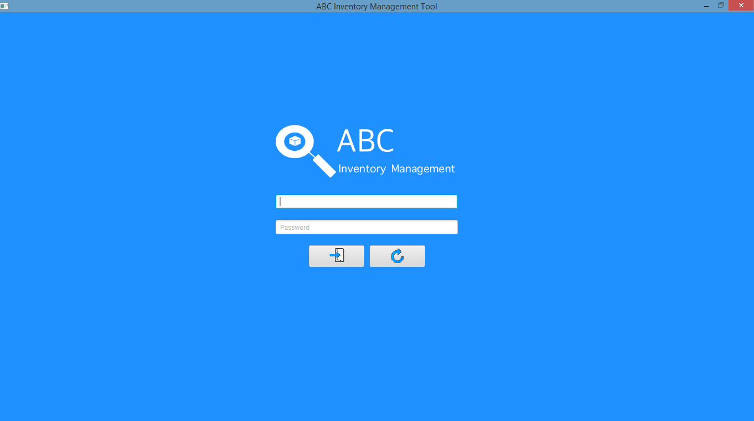

**Step 2**

Username and password are entered, and the system waits user to click on the ‘Login’ button.

**Step 3**

After the ‘Login’ button is pressed at step 2, access is granted, and the Homepage is displayed.

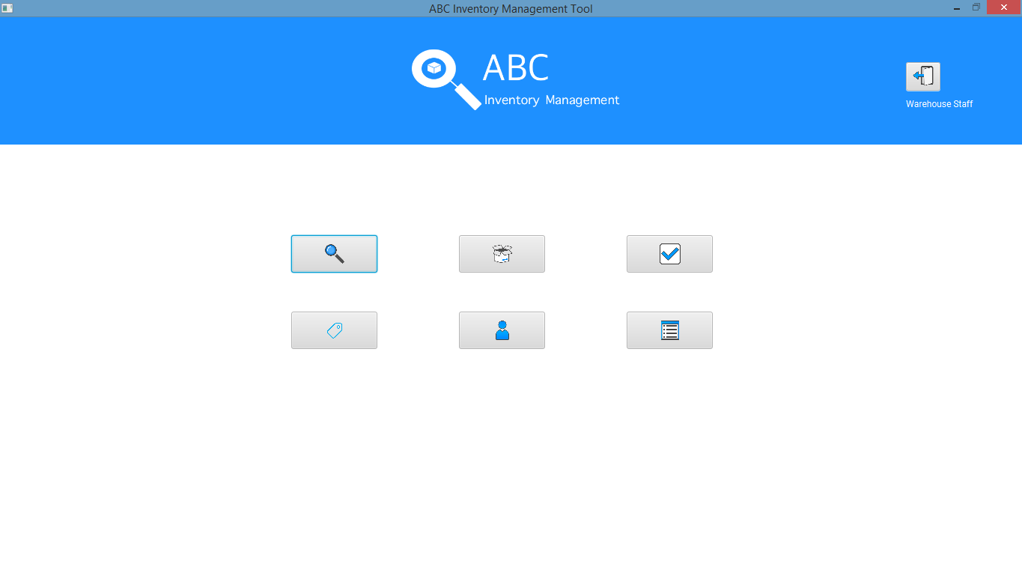

**Step 4**

**Step 5**

**Step 6**

**Step 7**

**Step 8**

**Step 9**

**Step 10**

**Step 11**

**Step 12**

# LI001 Login Script

## Script Description

This script follows each step while a store staff logs into the system using the updated password. It is assumed that the warehouse staff after updating the password has communicated the new password to the store staff. This script will check if each step while logging into the system using the updated password is a success. If any step fails to succeed, a bug will be reported, and the test will be conducted again.

## Testing Requirements

This test will cover the Login functionality of the system.

## Setup

* The computer in the location is powered on.
* Make sure the computer is connected to the internet.
* Application is launched.
* Store Staff password is updated and communicated to the store staff trying to login.

## Teardown

* User can access the system with store staff privileges.

## Script Steps

|  |  |  |  |
| --- | --- | --- | --- |
| Step | Test Action | Expected Results | Pass/Fail |
| 1. | Application is launched. | System displays the ‘Login’ Page with the Username and Password field empty. | Pass |
| 2. | Store staff with the updated password enters username and new password in the username and password field. | System waits till user to click on ‘Login’ button. | Pass |
| 3. | Click on the ‘Login’ button. | System grants access to the user and opens the Homepage with store staff privilege. | Pass |

### Result Screenshots

**Step 1**

Application launched, and login page is displayed.



**Step 2**

Username and password are entered, and the system waits user to click on the ‘Login’ button.

**Step 3**

After the ‘Login’ button is pressed at step 2, access is granted, and the Homepage is displayed with Store Staff privilege.

